
INTERNET PROGRAMMING AND MOBILE
PROGRAMMING

PROJECT 3: Design and Implementation of a Crowdsensed Drive Test
Mobile Application for Coverage Prediction

TASK 6: DATABASE DESIGN AND IMPLEMENTATION

GROUP 10

GROUP MEMBERS
 | Name Of Member | Matricule
1 | Asangana Paul Fleming | FE23A014
2 | Fontem Junior Nkonganyik | FE23A063
3 | Suinyuy Mathias Mahla | FE23A144
4 | Nfor Godwill Kongnje | FE23A108
5 | Ronald Namwene Vefonge | FE22A295

1. INTRODUCTION
The database serves as the backbone of the Crowdsensed Drive Test Mobile Application for Coverage Prediction. The primary purpose of the database is to store, organize, manage, and process large volumes of crowdsensed network measurements collected from smartphones operating as sensing devices. Unlike traditional drive testing systems that require expensive hardware and specialized vehicles, this system relies on ordinary smartphones to continuously collect network performance measurements and geographical information.

The database is designed to support continuous data collection, offline data storage, synchronization mechanisms, automated network analysis, coverage prediction, coverage hole detection, geographical visualization, reporting, and alert dissemination. Since the application does not require user registration or authentication, no personal user information is stored. Instead, the system focuses on anonymous device-generated measurements while maintaining user privacy.

2. DATA ELEMENTS
Data elements are the individual pieces of information collected, stored, and processed by the system. These elements provide the foundation for network analysis and coverage prediction.

2.1 Device Information Data Elements
Since the system operates anonymously, device information is used to uniquely identify data sources without storing personal user information.

Device ID
A unique identifier generated by the application.
Purpose:
- Uniquely identifies a sensing device.
- Prevents duplicate device records.
- Enables tracking of measurement origins.

Device Model
Examples:
- Samsung Galaxy A55
- Redmi Note 13
- Tecno Camon 30

Purpose:
- Allows comparison of measurements across device types.
- Supports hardware-specific performance analysis.

Operating System Version
Examples:
- Android 12
- Android 13
- Android 14

Purpose:
- Supports compatibility analysis.
- Assists debugging and maintenance.

Application Version
Purpose:
- Tracks software versions generating measurements.
- Supports update management.

2.2 Network Measurement Data Elements
These represent the most important data collected by the system.

Measurement ID
Unique identifier for each measurement record.

Purpose:
- Enables individual measurement tracking.

RSRP (Reference Signal Received Power)
Purpose:
- Measures signal strength.
- Used to determine network coverage quality.

RSRQ (Reference Signal Received Quality)
Purpose:
- Evaluates signal quality.

RSSI (Received Signal Strength Indicator)
Purpose:
- Measures total received radio power.

SINR (Signal-to-Interference-plus-Noise Ratio)
Purpose:
- Indicates network quality and interference levels.

Cell ID
Purpose:
- Identifies the serving cellular base station.

Network Type
Examples:
- 2G
- 3G
- 4G LTE
- 5G

Purpose:
- Enables network technology analysis.

Timestamp
Purpose:
- Indicates when measurements were collected.

2.3 Geographical Data Elements

Latitude
Purpose:
- Indicates geographical position.

Longitude
Purpose:
- Indicates geographical position.

Altitude
Purpose:
- Supports terrain-based coverage analysis.

Speed
Purpose:
- Determines whether measurements were collected while moving or stationary.

GPS Accuracy
Purpose:
- Measures the reliability of location information.

2.4 Temporary Storage Data Elements
These elements support offline operation, storing network measurement data when the device is offline.

Temporary Record ID
Purpose:
- Identifies locally stored records.

Storage Time
Purpose:
- Indicates when data was stored offline.

Synchronization Status
Possible Values:
- Pending
- Uploaded
- Failed
Purpose:
- Tracks synchronization progress.

2.5 Coverage Analysis Data Elements

Analysis ID
Purpose:
- Identifies each analysis record.

Coverage Score
Purpose:
- Numerical representation of network quality.

Coverage Classification
Possible Values:
- Good
- Acceptable
- Poor

Purpose:
- Determines map coloration.

Analysis Timestamp
Purpose:
- Records when analysis was performed.

2.6 Alert Data Elements

Alert ID
Purpose:
- Identifies generated alerts.

Alert Message
Purpose:
- Provides interpretation of network conditions.

Alert Type
Possible Values:
- Information
- Warning
- Critical

Purpose:
- Defines urgency level.

3. CONCEPTUAL DESIGN OF THE DATABASE
The conceptual design identifies the major entities involved in the system and defines how they interact.

3.1 Device Entity
The Device entity represents smartphones participating in crowdsensing activities.

Why it is Needed
The application does not maintain user accounts. Therefore, devices become the primary identifiable source of measurements.

Responsibilities
- Generate measurements.
- Store temporary data.
- Synchronize data.
- Receive alerts.

3.2 Measurement Entity
The Measurement entity is the most important component of the entire database.

Why it is Needed
All coverage analysis depends on network measurements collected by smartphones.

Responsibilities
- Store RSRP values.
- Store RSRQ values.
- Store RSSI values.
- Store SINR values.
- Store Cell IDs.
- Store timestamps.

3.3 Location Entity

Why it is Needed
Coverage prediction requires geographical positioning.

Responsibilities
- Store GPS coordinates.
- Enable coverage mapping.
- Support coverage hole detection.

3.4 Temporary Storage Entity

Why it is Needed
Many measurements are collected in locations with poor connectivity.
Without temporary storage:
- Data would be lost.
- Analysis accuracy would decrease.

Responsibilities
- Store offline measurements.
- Queue records for upload.
- Prevent data loss.

3.5 Synchronization Entity

Why it is Needed
Supports communication between mobile devices and cloud storage.

Responsibilities
- Monitor uploads.
- Track synchronization failures.
- Retry transmissions.

3.6 Coverage Analysis Entity

Why it is Needed
Raw measurements alone cannot provide meaningful insights.

Responsibilities
- Calculate coverage scores.
- Classify network quality.
- Generate prediction results.

3.7 Coverage Hole Entity

Why it is Needed
Identifies weak network regions.

Responsibilities
- Detect poor coverage zones.
- Store severity information.
- Support map visualization.

3.8 Alert Entity

Why it is Needed
Allows administrators to communicate network health information.

Responsibilities
- Store alerts.
- Deliver notifications.
- Interpret network conditions.

3.8.1 Relationships and Cardinalities between different entities
The table below summarizes the relationships shown in the conceptual diagram, including their cardinality and business meaning.

Entity A | Entity B | Cardinality | Description
Device | Measurement | 1 : N | A device generates many measurements over time.
Device | Sync Log | 1 : N | A device performs many synchronization attempts.
Measurement | Location | 1 : 1 | A measurement is recorded at exactly one location.
Measurement | Temp Storage | 1 : 1 | A measurement may be buffered in temporary storage pending upload.
Measurement | Coverage Analysis | 1 : 1 | A measurement is evaluated by one coverage analysis.
Coverage Analysis | Coverage Hole | 1 : N | A coverage analysis may identify multiple coverage holes.
Coverage Analysis | Alert | 1 : N | A coverage analysis may trigger multiple alerts.

3.8.2 Conceptual Diagram
The Figure below illustrates the conceptual data model using the Entity–Relationship notation, where entities are represented as ellipses, relationships as diamonds, and the connecting lines are labeled with cardinalities (1 for “one” and N for “many”).

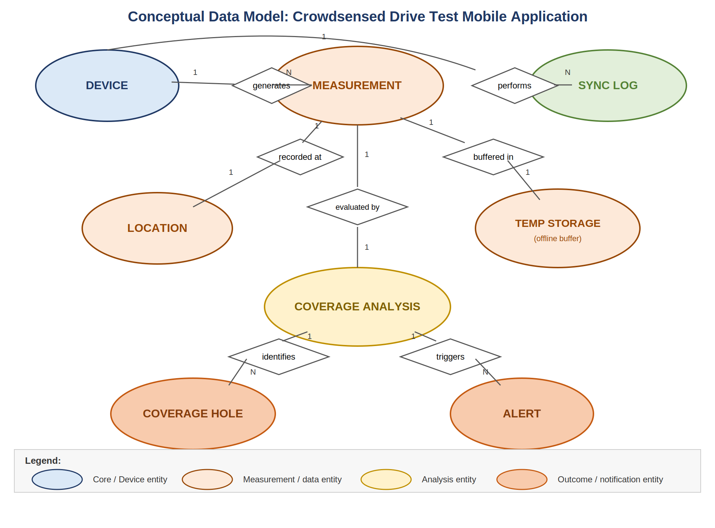

4. ENTITY RELATION DIAGRAM (ERD)

Table 1: Device

Purpose
Stores anonymous device information.

Attributes
- device_id (PK)
- device_model
- os_version
- app_version
- created_at

Table 2: Measurement

Purpose
Stores crowdsensed network measurements.

Attributes
- measurement_id (PK)
- device_id (FK)
- rsrp
- rsrq
- rssi
- sinr
- cell_id
- network_type
- timestamp

Table 3: Location

Purpose
Stores geographical coordinates.

Attributes
- location_id (PK)
- measurement_id (FK)
- latitude
- longitude
- altitude
- speed
- accuracy

Table 4: Temporary Storage

Purpose
Stores offline measurements.

Attributes
- temp_id (PK)
- measurement_id
- sync_status
- storage_time

Table 5: Synchronization Log

Purpose
Tracks uploads.

Attributes
- sync_id (PK)
- device_id (FK)
- sync_time
- upload_count
- sync_status

Table 6: Coverage Analysis

Purpose
Stores processed network results.

Attributes
- analysis_id (PK)
- measurement_id (FK)
- coverage_score
- coverage_status
- analysis_time

Table 7: Coverage Hole

Purpose
Stores poor network regions.

Attributes
- hole_id (PK)
- analysis_id (FK)
- latitude
- longitude
- severity
- detected_time

Table 8: Alert

Purpose
Stores notifications and administrative messages.

Attributes
- alert_id (PK)
- analysis_id (FK)
- title
- message
- alert_type
- created_at

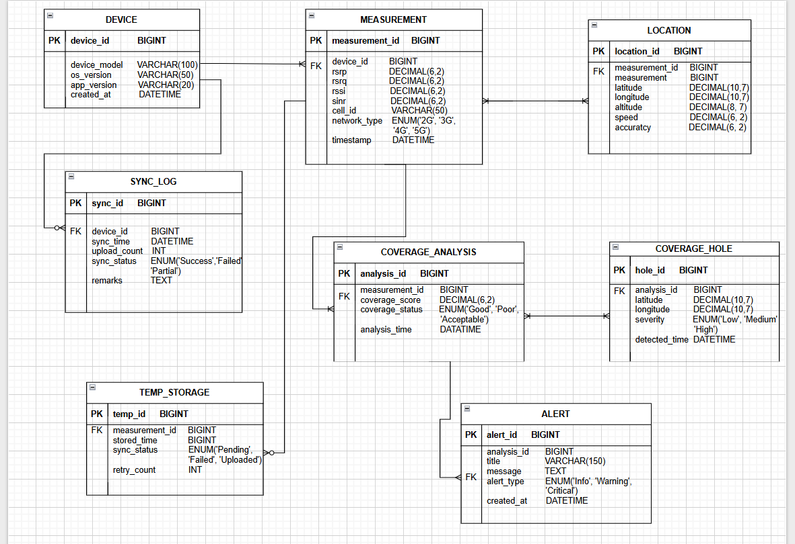

5.0 DATABASE IMPLEMENTATION
5.1 Introduction
This section presents the database design and implementation of the Crowdsensed Drive Test Mobile Application for Coverage Prediction. The purpose of the database is to provide a structured environment for storing, managing, processing, and retrieving crowdsensed cellular network measurements collected by smartphones operating as sensing devices. The database architecture was designed to support continuous data collection, offline storage, synchronization, coverage analysis, coverage prediction, coverage hole detection, administrative reporting, and user notification services.

The mobile application was developed using Flutter and Dart for the front-end, Node.js for the back-end, SQLite for temporary offline storage, and MySQL for permanent cloud-based storage. Together, these technologies provide a scalable and efficient platform capable of supporting large-scale crowdsensing operations while maintaining system reliability and performance.

5.2 ER Diagram Implementation into MySQL Database
Following the completion of the Entity Relationship Diagram, the conceptual database design was transformed into a physical MySQL database.

The ER Diagram served as the blueprint for database development. Each entity identified within the ER model was converted into a corresponding MySQL table. Relationships defined within the ER Diagram were implemented using primary keys and foreign keys to ensure referential integrity.

The following tables were created from the ER Diagram:
- Device Table: Stores information about participating devices.
- Measurement Table: Stores crowdsensed network measurements.
- Location Table: Stores geographical coordinates associated with measurements.
- Temporary Storage Table: Stores offline measurements waiting for synchronization.
- Synchronization Log Table: Tracks upload and synchronization activities.
- Coverage Analysis Table: Stores processed network quality results.
- Coverage Hole Table: Stores identified weak coverage regions.
- Alert Table: Stores notifications and interpretation messages generated by administrators.

Primary key constraints were implemented to uniquely identify each record, while foreign key constraints established relationships between tables. Database normalization techniques were also applied to reduce redundancy and improve consistency.

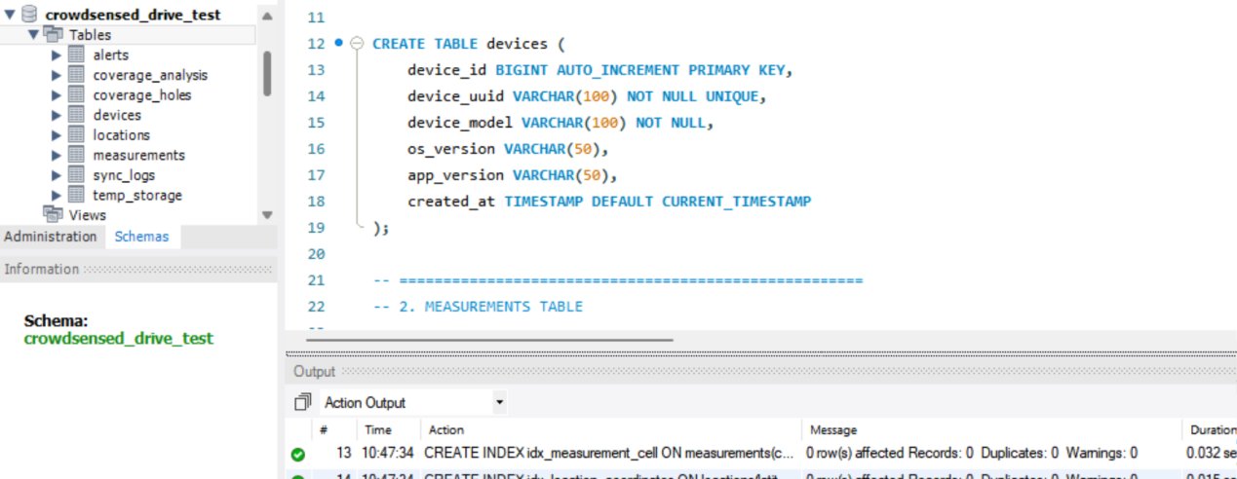
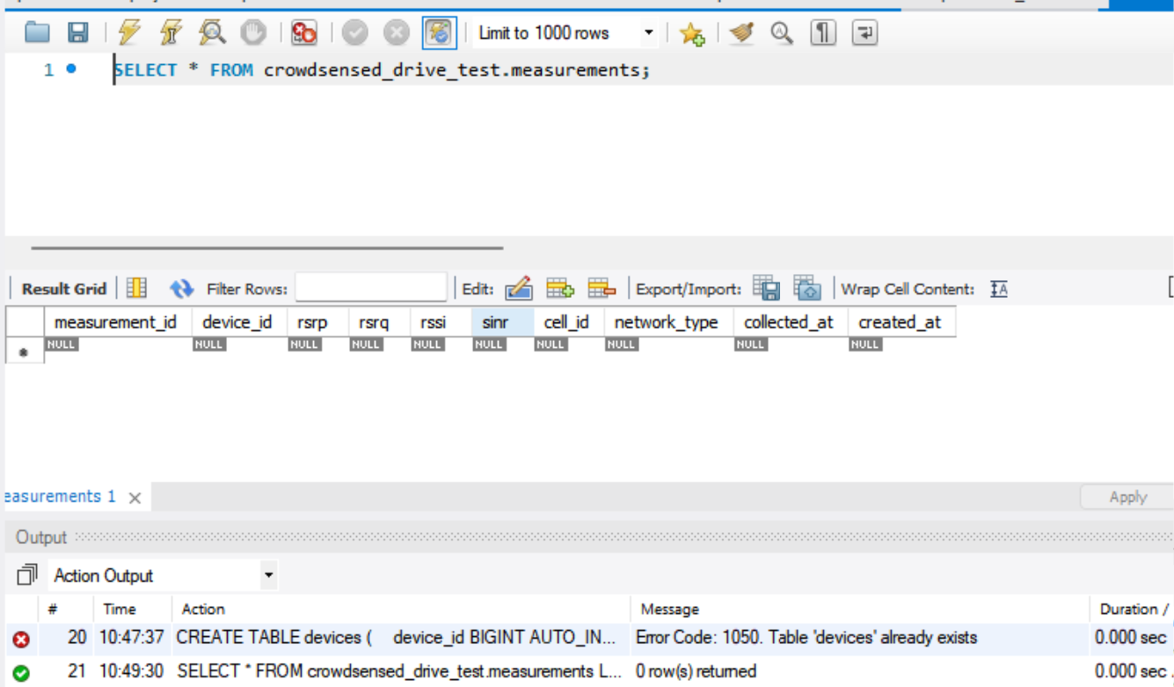

5.3 Offline Storage Using SQLite
- One of the most important features of the application is its ability to continue collecting measurements even when internet connectivity is unavailable.
- To achieve this, SQLite was integrated into the Flutter application as a local database solution.
- When the device loses connectivity, measurements are not discarded. Instead, they are stored temporarily in SQLite. This ensures that no valuable crowdsensed data is lost while users travel through from one regions to another.

The SQLite database stores:
- Measurement Data
- Location Data
- Collection Timestamps
- Synchronization Status

- Once internet connectivity becomes available, the synchronization module automatically uploads the stored measurements to the back-end server. The use of SQLite significantly improves system reliability and ensures uninterrupted data collection.

### Screenshot Area 4

**Insert Screenshot of SQLite Database Structure Here**

5.4 Back-end Implementation Using Node.js
The back-end component of the application was implemented using Node.js. Node.js was selected because it provides an event-driven, asynchronous, and non-blocking architecture capable of efficiently processing large volumes of crowdsensed measurements arriving simultaneously from multiple devices.

5.4.1 Importance of Node.js in the Back-end
- High Scalability: As the number of participating devices increases, Node.js can efficiently handle thousands of simultaneous requests without significant performance degradation.

- Real-Time Data Processing: The application continuously receives measurements from sensing devices. Node.js enables the back-end to process incoming data in real time.

- Fast API Development: Node.js provides an efficient environment for building RESTful APIs that support:

- Data Upload
- Data Retrieval
- Synchronization
- Coverage Analysis
- Alert Generation

- Efficient Resource Utilization: The asynchronous architecture minimizes resource consumption while maximizing throughput.

5.4.2 Backend Responsibilities
The Node.js back-end performs the following tasks:
- Receive crowdsensed measurements.
- Validate incoming data.
- Process measurement records.
- Store measurements in MySQL.
- Execute coverage analysis.
- Detect coverage holes.
- Generate alerts.
- Provide data to the Flutter front-end.

### Screenshot Area 6

**Insert Screenshot of Node.js Project Structure Here**

---

### Screenshot Area 7

**Insert Screenshot of Node.js API Endpoints Here**

5.5 Connecting MySQL Database to the Node.js Back-end
- The Node.js backend communicates directly with the MySQL database through a database connection layer.
- This connection acts as the bridge between application services and persistent storage.

- The connection process involves:
- Establishing a secure connection to MySQL.
- Creating database pools for efficient resource management.
- Executing SQL queries.
- Returning query results to back-end services.

- When measurements arrive from mobile devices:
- Node.js receives the request.
- Data validation is performed.
- SQL queries are executed.
- Records are stored in MySQL.

This architecture ensures reliable storage and efficient access to crowdsensed measurements.

### Screenshot Area 9

**Insert Screenshot of MySQL Connection Configuration Code Here**

---

### Screenshot Area 10

**Insert Screenshot Showing Successful MySQL Connection Here**

---

5.6 Connecting Flutter Front-end to the Node.js Back-end
- The Flutter mobile application communicates with the backend through RESTful APIs.
- This connection enables the exchange of data between the mobile device and server infrastructure.

5.6.1 Overall System Workflow
The complete workflow of the system is summarized below:
- Smartphones continuously collect network measurements.
- Measurements are stored locally in SQLite when offline.
- SQLite queues unsynchronized records.
- Upon reconnection, measurements are uploaded to Node.js APIs.
- Node.js validates and processes the received data.
- Measurements are permanently stored in MySQL.
- Automated analysis is performed.
- Coverage quality is classified.
- Coverage maps are generated.
- Coverage holes are identified.
- Administrators generate reports and visualizations.
- Alerts are sent to users.

### Screenshot Area 11

**Insert Screenshot of Flutter API Service Class Here**

6.0 CONCLUSION
- The Database Design and Implementation phase successfully transformed the conceptual ER Diagram into a fully operational database architecture capable of supporting large-scale crowdsensed network monitoring.

- The use of SQLite for offline storage ensures continuous data collection even in areas with poor connectivity, while MySQL provides a scalable and reliable environment for permanent storage and analysis. Node.js serves as a powerful back-end platform capable of processing large volumes of crowdsensed measurements, executing coverage analysis, and supporting real-time communication between system components. Flutter provides an efficient cross-platform front-end that enables data collection, synchronization, visualization, and user interaction.

- The successful integration of Flutter, SQLite, Node.js, and MySQL creates a robust architecture capable of supporting continuous crowdsensing, automated coverage prediction, coverage hole detection, administrative reporting, and user notification services. This architecture provides a practical and cost-effective alternative to traditional drive testing while enabling continuous monitoring of mobile network performance.

